

Nursing Rocks
(working title only)

Proposal Planning and Commencing
a Public Art Installation
Townsville Campus
in 2010
to mark the 20th anniversary
of The School of Nursing

prepared by
Dr. Linda Ashton
School of Education
James Cook University
0419713242

Public artworks help activate aspects of the University’s strategic intent and in particular, focusing our energies on advancing northern Queensland and northern Australia, and embracing the communities we serve and engaging with them at all levels, sharing a sense of pride in the University’s achievements. The School of Education has a proud and celebrated 10 year community engagement profile through public art projects in the local, tropical region. We have the commitment and skill to produce high quality forms which add interest and cultural identity to public spaces. The variety of media and forms we have produced is diverse and to date, our safety record has been impeccable. Quite a number of education students (now teachers) have subsequently undertaken similar projects successfully with their own pupils in schools. It is an invaluable and very different experience for them to see what can be achieved through collaborative art projects which benefit community, rather than the usual practice of making artworks for personal gain.

Following introductory discussions with HOS of Nursing Assoc. Prof. David Lindsay and staff enthusiasm for the “Nursing Rocks” concept, this document provides a more detailed project proposal. It outlines key factors – site, media & techniques, scale, symbolism, design drafts, timeline, budget, strategies for collaboration, publicity and multi-site participation, installation and maintenance. All funds (approx $5000) will be provided by The School of Nursing, hopefully with in kind and financial support from the University. Local tiling businesses have been very supportive of past SOE projects and may once again sponsor or discount tiles, glue and grout.

Symbolism and relevance to the tropics
The choice of a central large rock symbolises JCU as the hub of learning with satellite teaching sites in more remote centres, preparing graduates for the nursing profession and contributing to community health and well-being in our region. The timing of the work is to coincide with JCU’s twenty year history of producing nursing graduates. The key concepts behind the work are twofold: First, nursing was the foundation health program within James Cook University and remains numerically the largest most devolved program within the Faculty. Second, nurses and midwives are recognised as providing the foundation for ‘care’ within the health care system . Mosaic often symbolises that many small pieces are needed to realise an entity or goal. This metaphor suits the context of nursing preparation. To resonate with this place, the design will be colourful with semi-abstract, circular and possibly some plant or sea shapes (inspired by the late John Coburn’s iconic tropical designs). JCU has already completed 3 tribute mosaic murals to this internationally celebrated Ingham born artist (see Paradise Garden II, Primordial Garden II and Sun Canticle http://lindaashton.weebly.com/ II). Some faces of the large boulder or some of the satellite rocks could have more specific colours of Aboriginal and Torres Strait Islander significance, celebrating Indigenous nursing students and their communities. Final designs will also complement the specific form and contour of the host boulders. Sample maquettes and design ideas are attached.

Media, scale and techniques – The installation will feature one large rock approx 2m (h) x 1m x 1m with a number of smaller rocks around the base. The group of 4 or 5 boulders will be concreted into place with a 1m gravel surround and concrete curved edging. Overall the main work will cover a ground area of about 25 sqm. Surface adornment will be ceramic mosaic with some glass beads, decorative stones and possibly mirror mosaic feature sections. From initial discussions with JCU Facilities Management staff there appear to be suitable rocks on-campus and access to heavy machinery for lifting, transporting and installing.

Site – The intended site is outdoors adjacent to the School of Nursing building. A number of suitable positions will be marked for Facilities Management confirmation following cable and other underground checks, garden maintenance or other access issues. One preferred site is at the rear of the building among the trees. Students sit nearby for lunch, between classes and for social interaction. The bright artwork will mark their learning place with a unique form and special tropical colours. Placement of the work in this public outdoor space will benefit students, staff and visitors to the building with a tangible, lasting reminder of the value of the work done in the School. A second position and in a more noticeable public location is at the front of the building on the grass near the road, pedestrian crossing and bus stop. Some of the smaller rocks can double as seating, fulfilling the philosophy of art and people interacting directly. Given that the supply of most rocks will be much easier than first anticipated, it may be possible to have two smaller clumps in both preferred sites.

Safety and QA – The heavier work will be undertaken by JCU FMO with transport of boulders, installation and concreting completed by tradespeople with appropriate skills and equipment. Project management and design will be done by Linda Ashton, School of Education with artists/students from the School of Education completing most of the mosaic work indoors at JCU. Local mosaic artist Janine Jumeau will assist and be paid for her professional contribution, assisted by SOE graduate artists who will also be remunerated. The art room in D Block Western campus has most safety equipment, suitable storage and supervision capacity. All mosaic work completed by School of Education has smooth-to-touch finish ensuring no risk to the public. Nursing staff and students in Townsville and satellite sites who were interested could also be involved in the mosaic making process. Small boxes of tiles and glue could be posted to them with instructions for completion and safe practices. Shapes will be carefully pre-drawn onto mesh for unity of design and colour harmony. Skype and other digital communications with project manager and employed artists will facilitate the distance participation process. Once returned, the mosaic sections will be combined with on-campus pieces for attaching to the boulders and grouting. The gluing and grouting of the various mosaic designs to the boulders will be done on-site and in shadier times of the day. Grinding of any sharp edges will require access to an electrical outlet inside the building and a long safety tagged extension cord. QA processes will be implemented at each stage of the making process (sample form attached) with attention to unity and suitability of design. All participants will complete media release, safety and QAP forms to be stored in School of Nursing files. Records of the project’s completion will be kept by project manager, stored digitally and a copy provided for School of Nursing records.

Cost – $5000
Approx $1000 for supply and professional installation of large rocks on site. Approx $1000 for each artist and $1000 for materials - glue, backing mesh, grout, tiles, glass stones, mirror and safety equipment. School of Education has some items already including tiles, hammers, nippers, goggles, grinding tools, gloves mirror and glass. If local industry agrees to sponsoring then materials costs may be less. A wall-mounted plaque (approx $50) will be installed nearby for public information. Beyond the art materials, School of Nursing will need to fund an official launch with light refreshments for invited guests. There will also be some postage and printing costs. HOS of Nursing will establish a special account for the project and monitor/process all purchasing/payments. The project manager will submit receipts for local purchases of project materials to HOS for cash reimbursement.

Durability and shelf life – Being a very durable medium, protected somewhat from the elements, the mosaic work could last 30+ years. Annual maintenance and cleaning checks by FMO will add to the expected lifespan of the work. Minor cracking along grout lines might occur with extreme changes of temperature however this is easily repaired with additional grout application and /or Weldbond glue.

Other public art issues to consider
Design ownership - intellectual property will belong to project manager/designer. The usual design/consultancy fee will be waived for this on-campus work.
Privacy - for web or other publicity/promotion a specific media release form will be developed for participant authorisation so photographic records can be shared (sample attached).
Security (vandalism/theft) -There is minimal risk of theft or vandalism due to site, weight and durability of media. Installation of a spotlight mounted on the adjacent building will benefit the work aesthetically and also add further security at night. In the event of graffiti, spray paint is removed easily with turpentine or similar solvent.
Public liability – as an in house project all participants are to be covered by University insurance.
Signage – a wall mounted didactic will be locally made by Twin Cities Trophies.

Publicity, fundraising and community involvement
Promotion of the project will commence with in-house discussions in the School of Nursing, inclusion in School/Faculty meeting agendas and reports, email and website features. A competition will be arranged for naming of the final work. A blog option on the School’s web page would encourage further staff and student interest and information about progress. This could be complemented by local, print /radio media snippets and possibly a School of Journalism interview. A wall mounted ‘Nursing Rocks’ noticeboard within the School, for colour imagery and information snippets would keep students updated.

Fostering links between staff and students in various participating sites
Staff and students will be invited to help with mosaic work at School of Education or in suitable spaces at the various Nursing Sciences hubs. Past graduates and members of the nursing/health care fraternity at various sites might also be invited to participate in a weekend or specially arranged mosaic workshop. Any site specific or cultural imagery will require written confirmation from community sources that permission is given to use the designs. Nursing Sciences will organise an official unveiling, dedication ceremony and Welcome to Country, inviting artists, university representatives, media and community members, and providing light refreshments. Upon completion images of the work and the making process will be available for JCU web page promotion. A well sized quality mounted digital photo of the finished work will be sent to participating hubs in remote sites.

Project manager and design co-ordinator will supervise all art work directly or via digital mode, collaborating with HOS School of Nursing and Facilities Management Office staff to bring this exciting project to completion.

Draft timeframe for completion
Dates Milestone Personnel
July/Aug 2009 | project proposal and approval  site selection | Project manager, HOS and FMO
Aug/Sept 2009 | sponsorship effort, sourcing of boulders and art materials order, contracts for artists prepared | Project manager  HOS
Sept/Oct 2009 | site preparation,  transport & installation of boulders, design drafts | FMO & possibly outside rock and gravel supplier
Nov 2009-Feb 2010 | project admin/participation plan and design finalisation | Project manager with HOS
March - April 2010 | mosaic work | Project manager, artists and Nursing Science participants
May 2010 | glue, grout mosaic sections onto boulders and grind edges | Project manager, Artists
end June 2010 | didactic, lighting, official handover | Project manager, HOS & staff, FMO

The section below provides key signatories which confirm that this proposal is approved, the project active and insurance cover is in place for participants.

Assoc. Prof. David Lindsay Head of School Nursing

.................................................................. Date .................................................

Mr. Peter Hill Facilities Management Office

.................................................................. Date .................................................

SAFETY CONTRACT FOR JCU PUBLIC ART PROJECTS

Before engaging in practical art techniques in the construction of public art works for the university, participants are required to agree to conditions which will maximise safety and facilitate unity of design. While all care will be taken during the art making time, the Public Art Project may involve some medium and potentially high risk tools/techniques. It is essential that participants commit to safe working practices at all times to maintain our accident free history in the genre. It is also essential to commit to Quality Assurance Partnerships (QAP) to ensure a high quality finish in the chosen media. Please consider and initial each item below as consent, before engaging in any practical activities.

I ………………………………………………………………….. agree to the following safety & quality assurance protocols:

• to take full care when working with others including lifting, and to ask questions
if further clarification is needed or to ask for additional demonstration if needed

• to observe carefully and take notes for all technique demonstrations and safety tips
provided regarding correct use of tools and equipment,

• to complete artist’s log & QAP information

• to accept design and technique suggestions provided by the project co-ordinator
to achieve unity among the various pieces,

• to maintain a clean working bench and floor space at all times including protecting
table tops with newspaper, towels or plastic underlays before commencing
prac work and care for all equipment /tools supplied for making artworks

• to seek assistance from the project manager for clarification of any query
concerning, technique, process, media or protocol.

• to wear enclosed shoes at all times in the work area, a safety mask, apron,
gloves when advised - to use varnish or any other fume media (turps cleanup)
outdoors so the air in enclosed spaces is not contaminated

• to report any accidents or feelings of being unwell, however minor for
immediate response and/or first aid treatment

Please list on reverse of form any specific health issues, medical history or concerns that may restrict
or prevent your full participation in this project so modified activity / alternatives are negotiated and approved.

Signed ……………………………………………. Date …………………………………..

Witness’ Name ……………………………………….. Signature …………………………………

MEDIA RELEASE FORM
for
Nursing Rocks Public Art Project Participants
2009 - 2010

Full Name :

……………………………………………………………………………………
(Please print clearly)

Phone/email contacts :

……………………………………………… …………………………………

Give permission for photos of me /individual (including face) to be used by Dr. Linda Ashton, for educational and publication purposes in print and/or electronic form.
I understand that the photos may be used for promotion of visual art activity by JCU to various audiences including online, local press, conference and research forums.

Signature : …….…………………………………………….. Date : ………………

Witness :

Name ……………………………………………………..

Signature : …….…………………………………………….. Date : ………………

James Cook University
School of Education 2009/10
PAQAP Form
Public Art Quality Assurance Process

Name of Artist

………………………………………………………………..

Each artist must ensure that their work is checked each session and initialled by a QAP (Quality Assurance Partner) or the Project Manager. Any feedback, suggestions by QAP for higher quality finish should be listed and addressed by the maker. This form must be submitted by every participant.

Names of Quality Assurance Partners (QAP)

…………………………………………………………………………………

…………………………………………………………………………………

……………………………………………….………………………………..

Try to have various monitors.

Name of Artist : ………………………………………….. Project Title : …………………………………………………….

Date & time + work site | Description of work completed –  Design section/activity, media, tools and techniques used.  Safety measures taken | Comment /recommendation by QAP or Project Manager | Initials only when work is approved

Rock maquettes and mosaic technique
Sample Coburn imagery Paradise Garden (Coburn Tapestry)
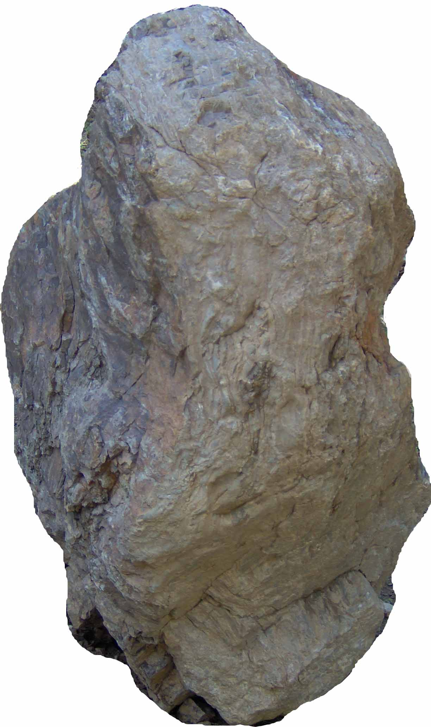
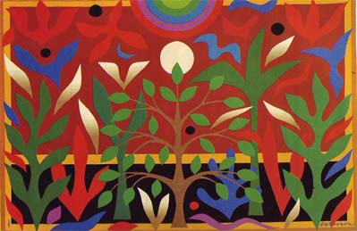
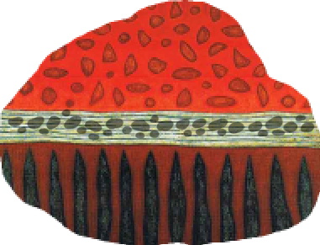
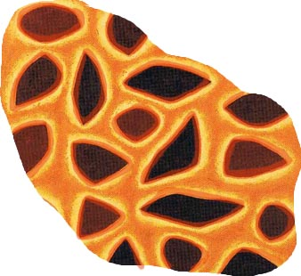
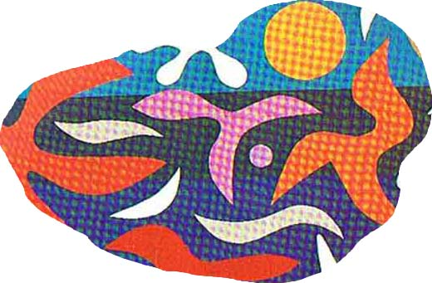
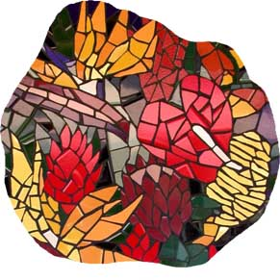
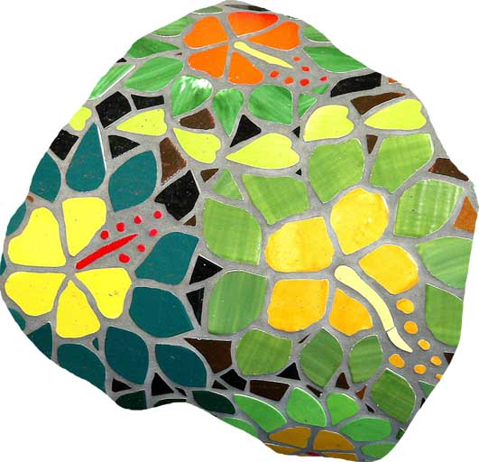
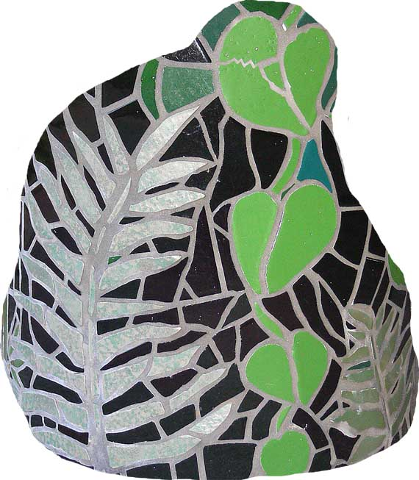
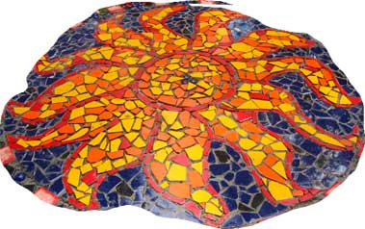
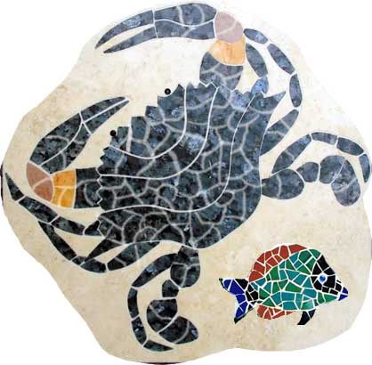
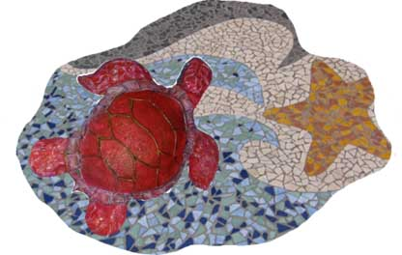
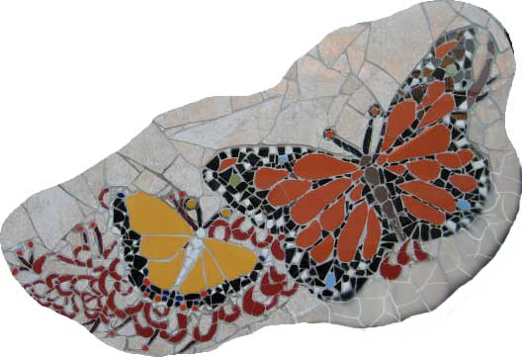
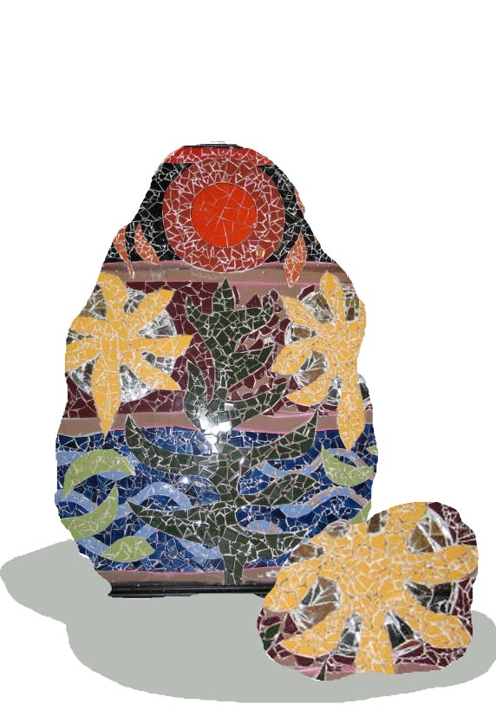
Maquette 1
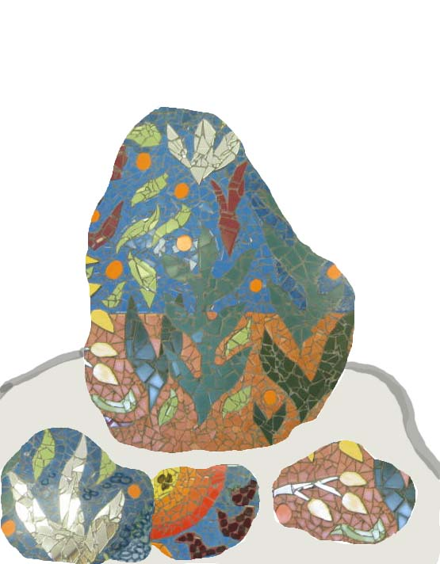
Maquette 2
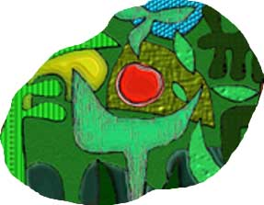
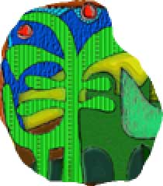
Maquette 3
Maquette 4

